ACTIVIDAD 1 – MOMENTO INDEPENDIENTE – UNIDAD 3 ESTUDIANTE VIRTUAL SST TATIANA CRIOLLO FLOREZ

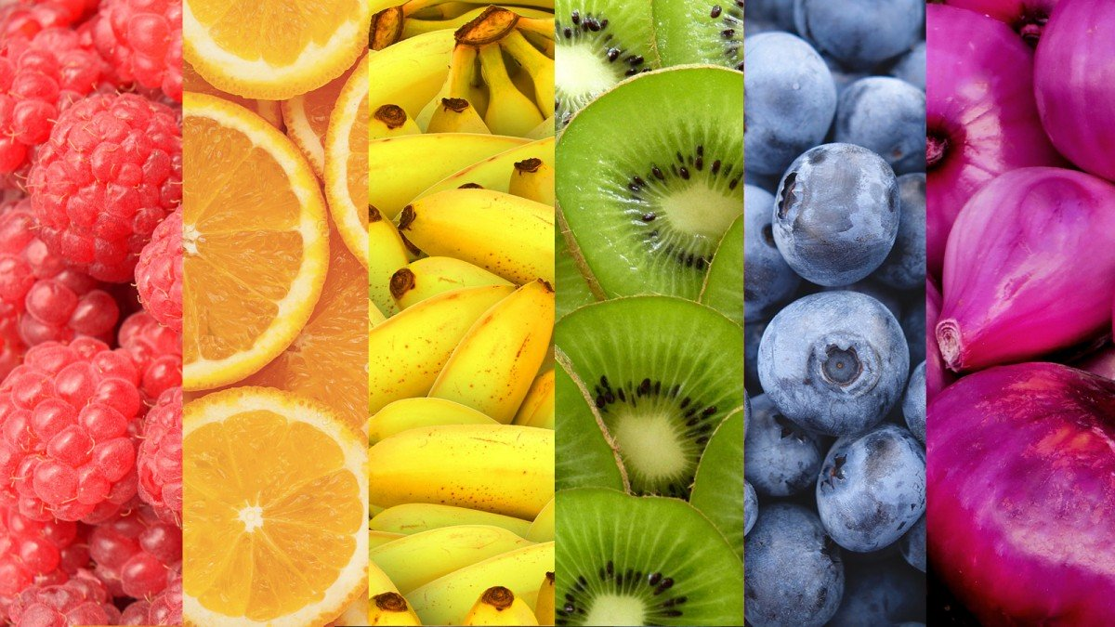

1

**10 FRUTAS**

* **MELON * CANTALOUPE**
* **SANDIA * SANDIA**
* **MANZANA * APPLE**
* **UVA * UVA**
* **PERA * PEAR**
* **MELOCOTON * PEACH**
* **COCO * COCO**
* **PIÑA * PIÑA**
* **PAPAYA * PAPAYA**
* **MANGO * MANGO**

**10 VERDURAS**

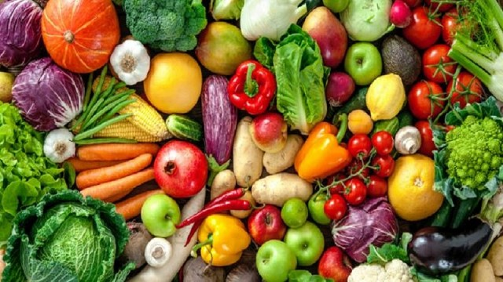

* **BROCOLI * BROCCOLI**
* **LECHUGA * LETTUCE**
* **PEPINO * CUCUMBER**
* **APIO * APIO**
* **PEREJIL * PEREJIL**
* **AJO * GARLIC**
* **ESPINACA * SPINACH**
* **TOMATE * TOMATO**
* **ZANAHORIA * CARROT**
* **BERENJENA * EGGPLANT**

**10 UTENCILIOS**

* **CUCHARA * SPOON**
* **TENEDOR * FORK**
* **CUCHILLO * KNIFE**
* **VASO * GLASS**
* **PLATO * PLATE**
* **POSILLO * POSITION**
* **BATIDOR * MIXER**
* **COLADOR * COLADOR**
* **SARTEN * PAN**
* **PITILLO * PITILLO**

**AUDIO** [**https://drive.google.com/open?id=1ZwqL6rnjfyyf4EiAEyiUvXQplCCd_bt5**](https://drive.google.com/open?id=1ZwqL6rnjfyyf4EiAEyiUvXQplCCd_bt5)

**2 GRAVE UN AUDIO DEL SIGUIENTE TEXTO**

Hello my favorite fruits are apples and grapes; I don't like desserts are very sweets, but if I have to eat vegetables. I prefer to eat beans and carrots, they are delicious. I really like eggs and orange juice that is my favorite breakfast.

**AUDIO** [**https://drive.google.com/open?id=14GYBKDhUzzuwGGbQnY9QITe5VlYQ85UM**](https://drive.google.com/open?id=14GYBKDhUzzuwGGbQnY9QITe5VlYQ85UM)